[](https://ok.ru/dk?cmd=PopLayerPhoto&st.layer.cmd=PopLayerPhotoOuter&st.layer.type=GROUP&st.layer.revNav=off&st.layer.limitedUi=false&st.layer.sphotoIds=838217571945%3B838217571689%3B838217571433%3B838217571177%3B838217570921%3B838217570665%3B838217570409%3B838217570153&st.layer.showNav=on&st.layer.photoAlbumId=53647148187753&st.layer.epm=off&st.layer.photoId=838217571945&st.layer.opl=off&st.layer.navStartPhotoId=838217571945&st.layer.sbd=off&st.cmd=userMain&st._aid=GroupTopicLayer_openPhotoLayer)

[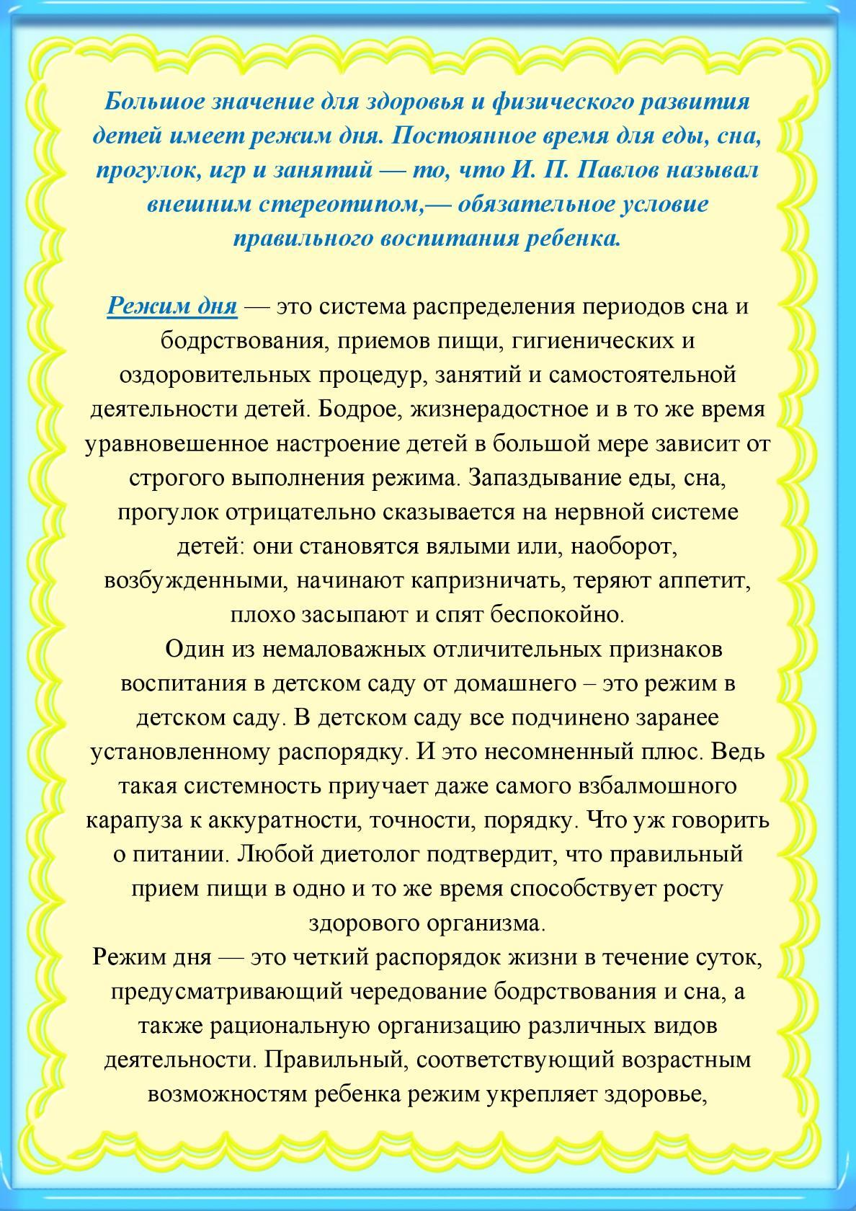](https://ok.ru/dk?cmd=PopLayerPhoto&st.layer.cmd=PopLayerPhotoOuter&st.layer.type=GROUP&st.layer.revNav=off&st.layer.limitedUi=false&st.layer.sphotoIds=838217571945%3B838217571689%3B838217571433%3B838217571177%3B838217570921%3B838217570665%3B838217570409%3B838217570153&st.layer.showNav=on&st.layer.photoAlbumId=53647148187753&st.layer.epm=off&st.layer.photoId=838217571689&st.layer.opl=off&st.layer.navStartPhotoId=838217571689&st.layer.sbd=off&st.cmd=userMain&st._aid=GroupTopicLayer_openPhotoLayer)

[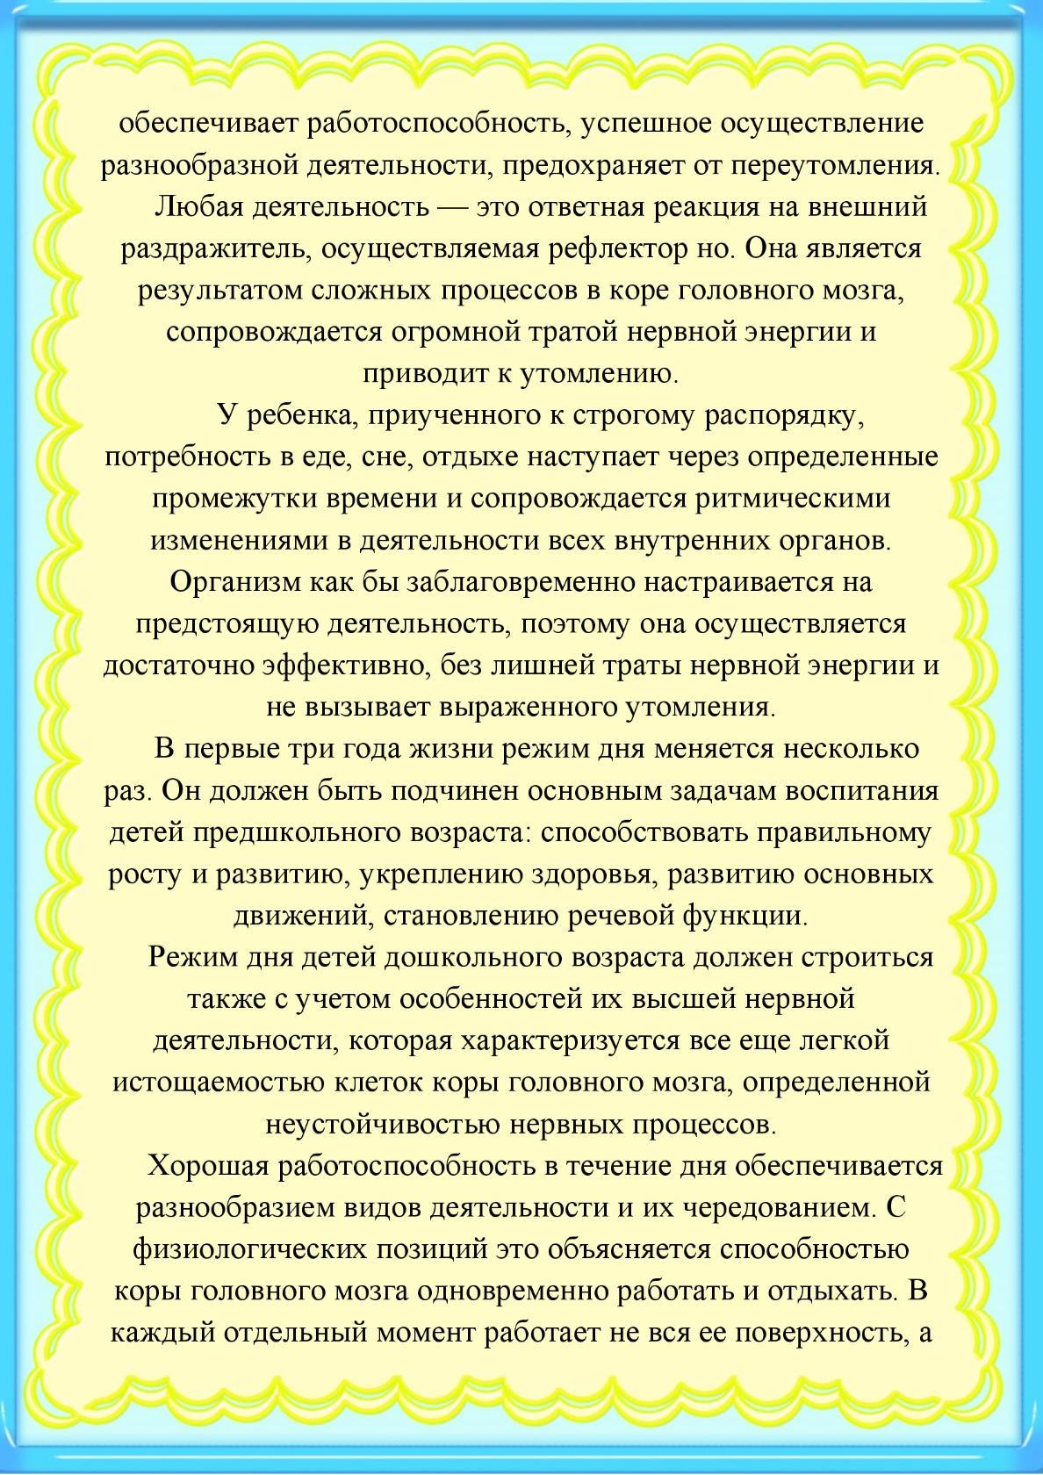](https://ok.ru/dk?cmd=PopLayerPhoto&st.layer.cmd=PopLayerPhotoOuter&st.layer.type=GROUP&st.layer.revNav=off&st.layer.limitedUi=false&st.layer.sphotoIds=838217571945%3B838217571689%3B838217571433%3B838217571177%3B838217570921%3B838217570665%3B838217570409%3B838217570153&st.layer.showNav=on&st.layer.photoAlbumId=53647148187753&st.layer.epm=off&st.layer.photoId=838217571433&st.layer.opl=off&st.layer.navStartPhotoId=838217571433&st.layer.sbd=off&st.cmd=userMain&st._aid=GroupTopicLayer_openPhotoLayer)

[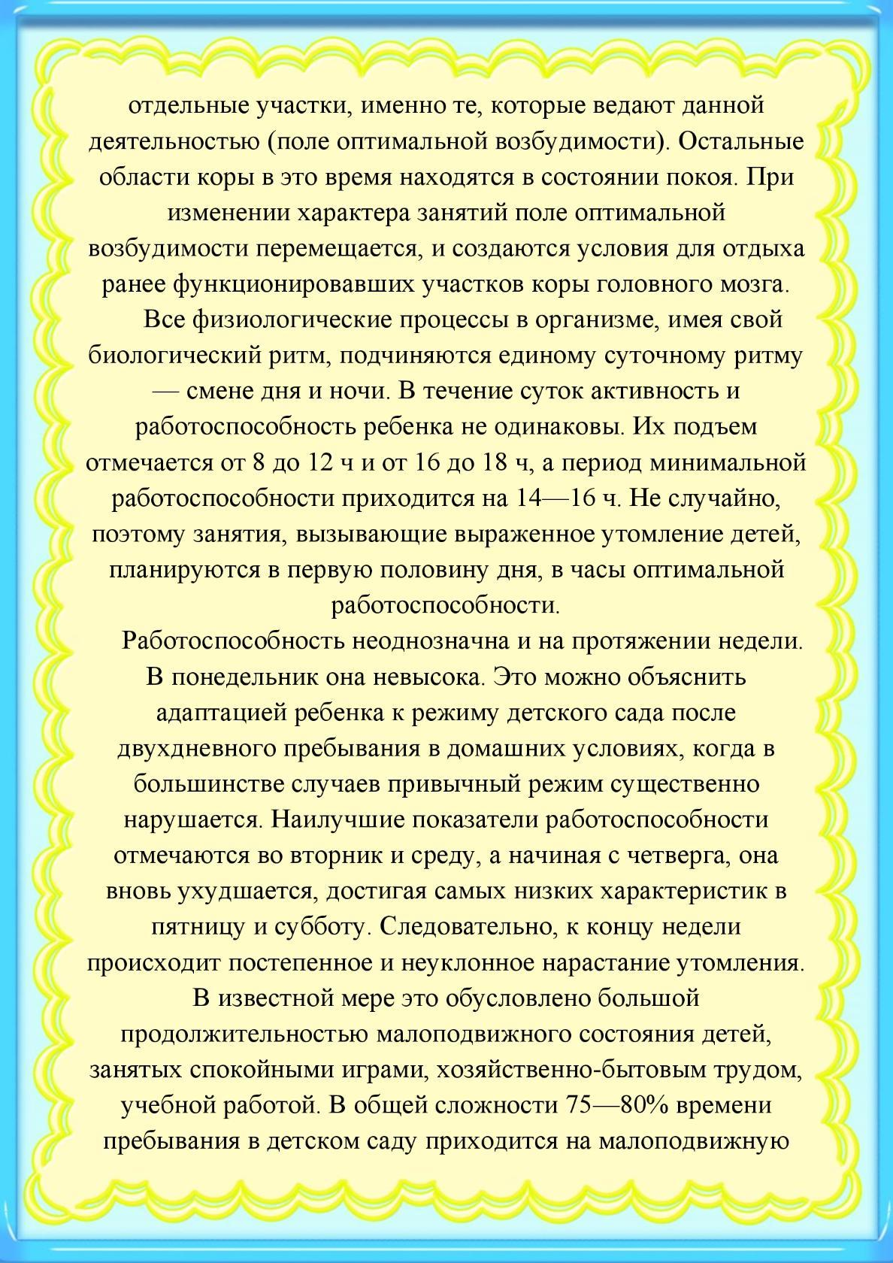](https://ok.ru/dk?cmd=PopLayerPhoto&st.layer.cmd=PopLayerPhotoOuter&st.layer.type=GROUP&st.layer.revNav=off&st.layer.limitedUi=false&st.layer.sphotoIds=838217571945%3B838217571689%3B838217571433%3B838217571177%3B838217570921%3B838217570665%3B838217570409%3B838217570153&st.layer.showNav=on&st.layer.photoAlbumId=53647148187753&st.layer.epm=off&st.layer.photoId=838217571177&st.layer.opl=off&st.layer.navStartPhotoId=838217571177&st.layer.sbd=off&st.cmd=userMain&st._aid=GroupTopicLayer_openPhotoLayer)

[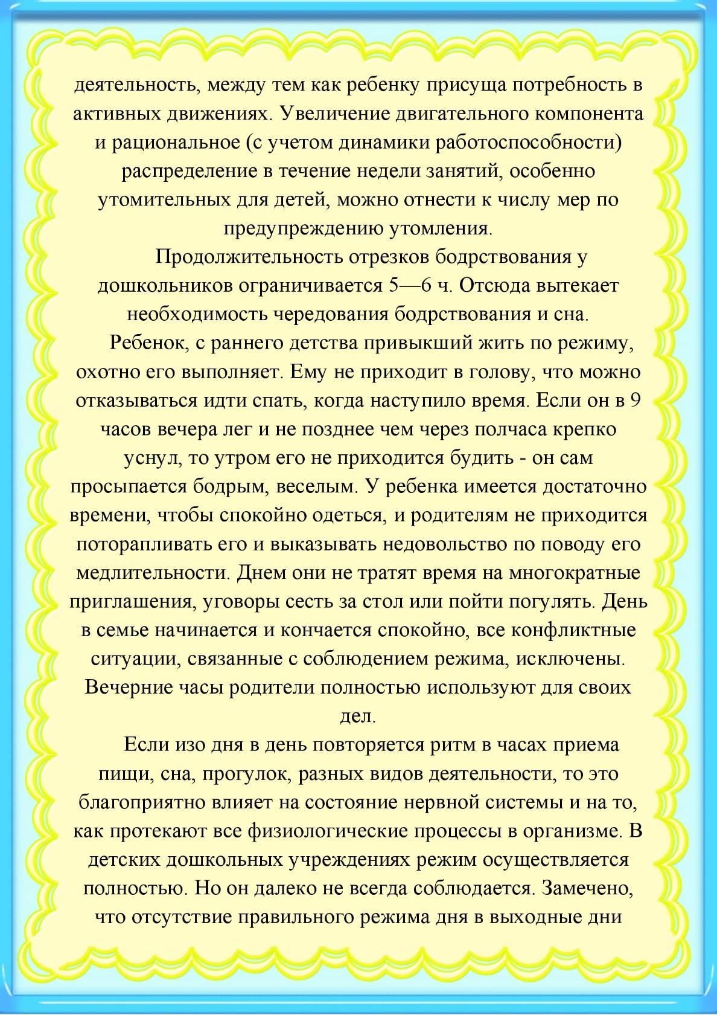](https://ok.ru/dk?cmd=PopLayerPhoto&st.layer.cmd=PopLayerPhotoOuter&st.layer.type=GROUP&st.layer.revNav=off&st.layer.limitedUi=false&st.layer.sphotoIds=838217571945%3B838217571689%3B838217571433%3B838217571177%3B838217570921%3B838217570665%3B838217570409%3B838217570153&st.layer.showNav=on&st.layer.photoAlbumId=53647148187753&st.layer.epm=off&st.layer.photoId=838217570921&st.layer.opl=off&st.layer.navStartPhotoId=838217570921&st.layer.sbd=off&st.cmd=userMain&st._aid=GroupTopicLayer_openPhotoLayer)

[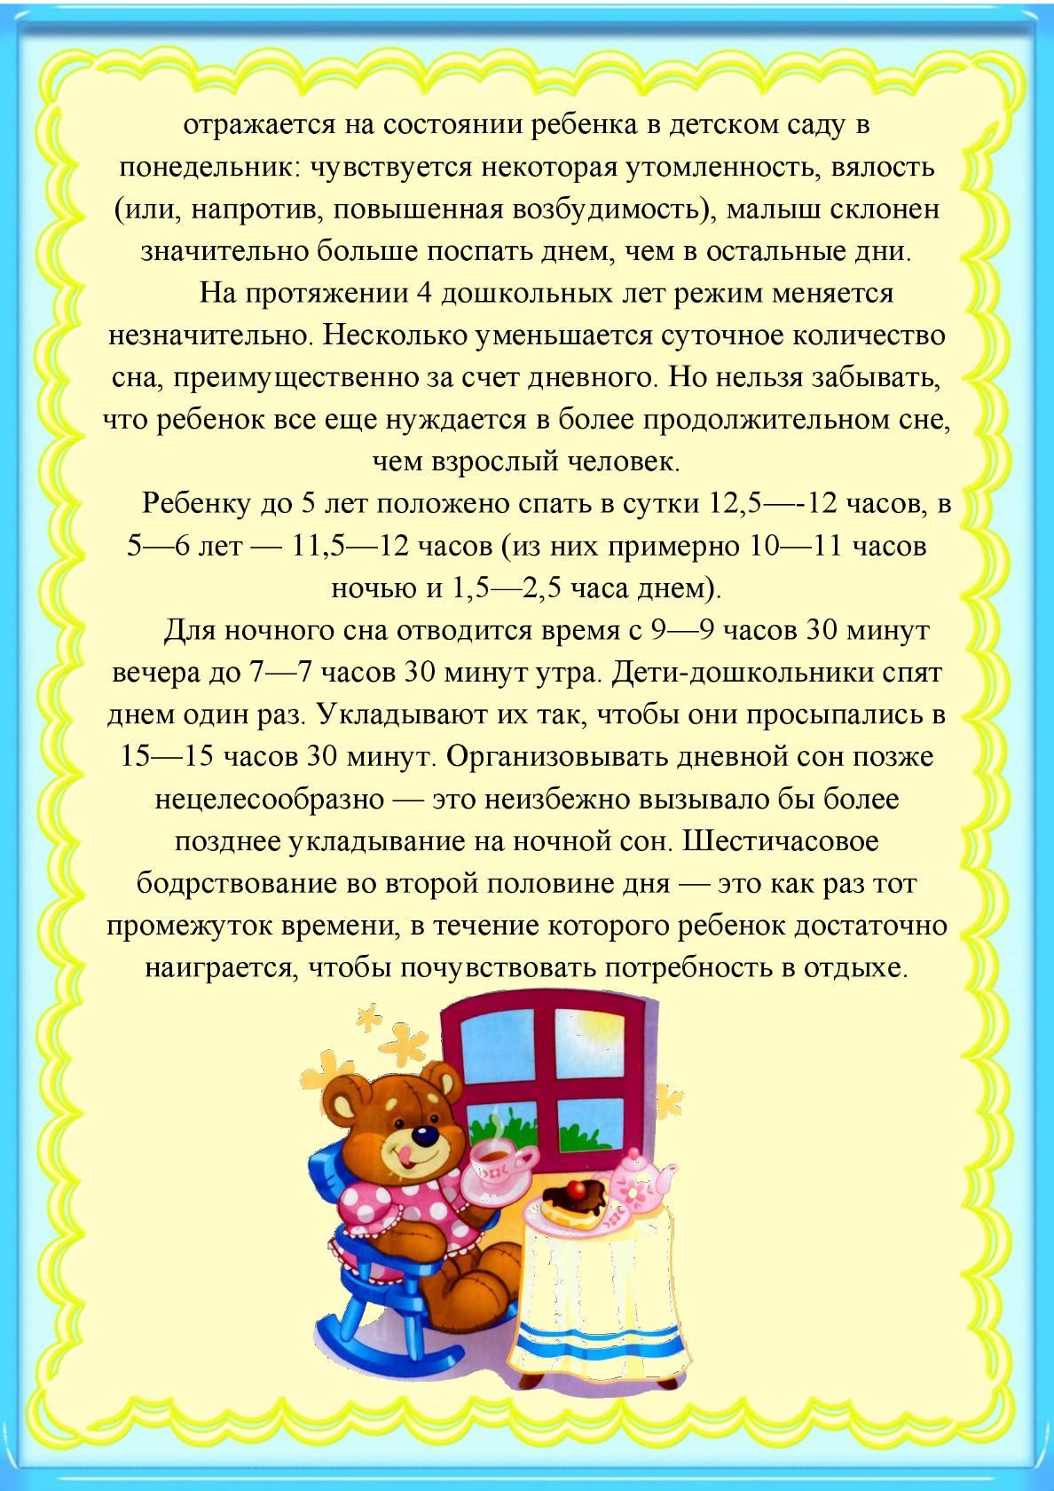](https://ok.ru/dk?cmd=PopLayerPhoto&st.layer.cmd=PopLayerPhotoOuter&st.layer.type=GROUP&st.layer.revNav=off&st.layer.limitedUi=false&st.layer.sphotoIds=838217571945%3B838217571689%3B838217571433%3B838217571177%3B838217570921%3B838217570665%3B838217570409%3B838217570153&st.layer.showNav=on&st.layer.photoAlbumId=53647148187753&st.layer.epm=off&st.layer.photoId=838217570665&st.layer.opl=off&st.layer.navStartPhotoId=838217570665&st.layer.sbd=off&st.cmd=userMain&st._aid=GroupTopicLayer_openPhotoLayer)

[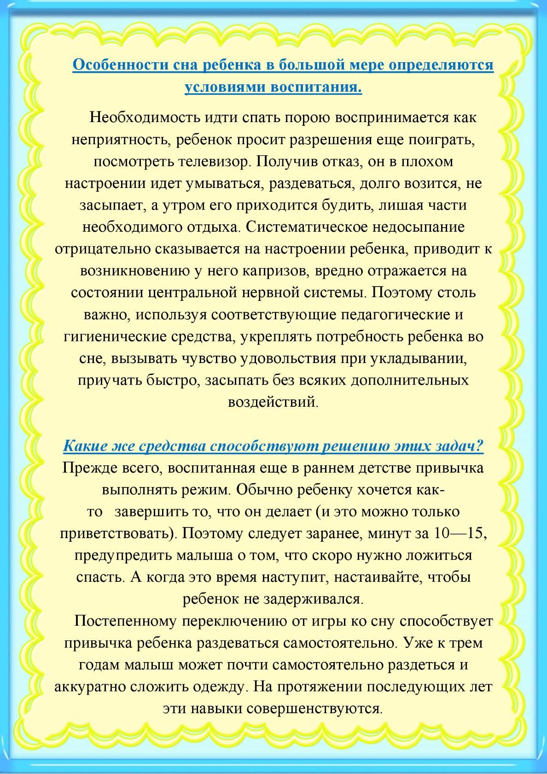](https://ok.ru/dk?cmd=PopLayerPhoto&st.layer.cmd=PopLayerPhotoOuter&st.layer.type=GROUP&st.layer.revNav=off&st.layer.limitedUi=false&st.layer.sphotoIds=838217571945%3B838217571689%3B838217571433%3B838217571177%3B838217570921%3B838217570665%3B838217570409%3B838217570153&st.layer.showNav=on&st.layer.photoAlbumId=53647148187753&st.layer.epm=off&st.layer.photoId=838217570409&st.layer.opl=off&st.layer.navStartPhotoId=838217570409&st.layer.sbd=off&st.cmd=userMain&st._aid=GroupTopicLayer_openPhotoLayer)

[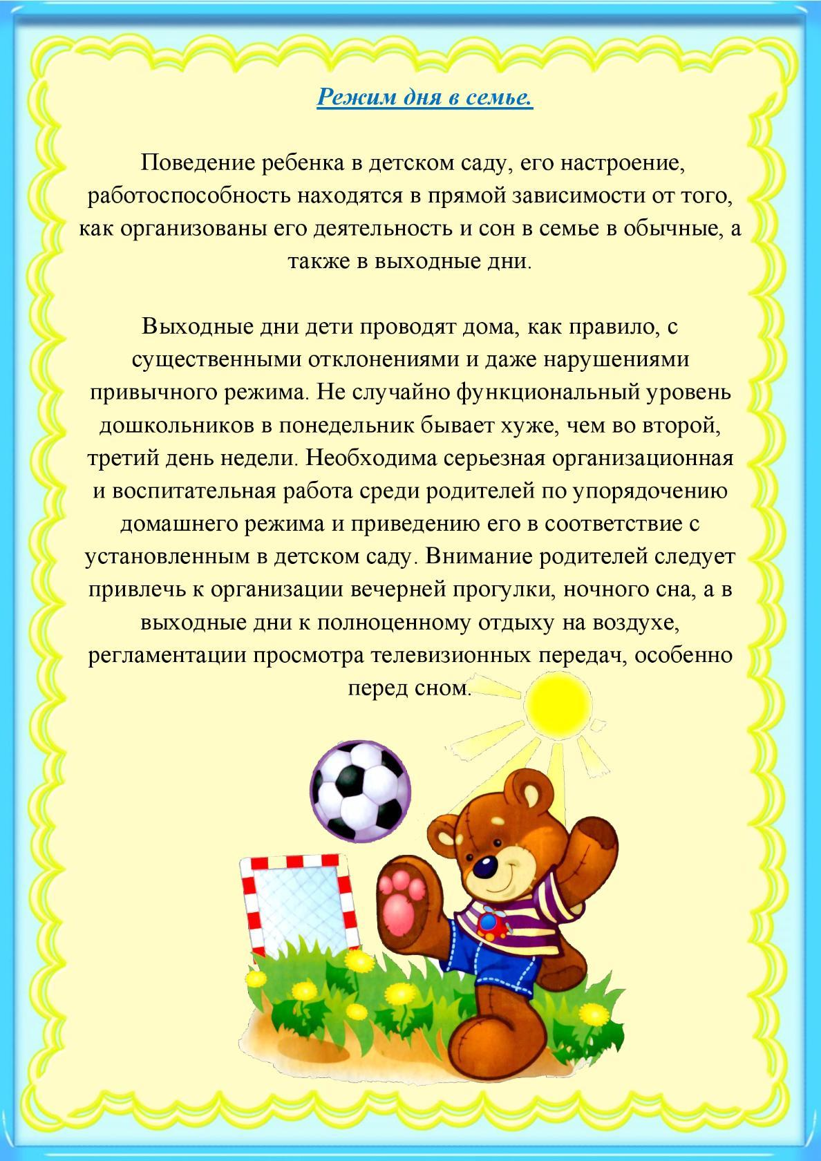](https://ok.ru/dk?cmd=PopLayerPhoto&st.layer.cmd=PopLayerPhotoOuter&st.layer.type=GROUP&st.layer.revNav=off&st.layer.limitedUi=false&st.layer.sphotoIds=838217571945%3B838217571689%3B838217571433%3B838217571177%3B838217570921%3B838217570665%3B838217570409%3B838217570153&st.layer.showNav=on&st.layer.photoAlbumId=53647148187753&st.layer.epm=off&st.layer.photoId=838217570153&st.layer.opl=off&st.layer.navStartPhotoId=838217570153&st.layer.sbd=off&st.cmd=userMain&st._aid=GroupTopicLayer_openPhotoLayer)